1

National Childcare Prices
Subash Karthick Suriyamurthy
Bellevue University

Introduction
This project investigates the National Database of Childcare Prices to understand how childcare costs vary across the United States. The dataset offers detailed county-level information, including state and county identifiers, the year of observation, and various childcare price metrics for different provider types—such as center-based and family childcare—across various age groups, including infants, toddlers, and preschoolers. To better analyze pricing patterns, I conducted thorough data exploration, generated descriptive statistics, and created multiple visualizations that highlight regional and temporal trends.
Business Problem/Research Questions:
Childcare affordability has become a significant economic and social challenge in the United States. For many families, childcare represents one of their largest recurring expenses, often rivaling the costs of housing and healthcare. Rising childcare prices can create considerable financial strain on families, influence labor force participation—especially among parents of young children—and contribute to broader inequalities across different regions and income levels.
Despite its importance, the cost of childcare is not uniform throughout the country. Prices vary significantly based on geographic location, the type of childcare provider (such as center-based versus family-based care), and the child's age group (infant, toddler, or preschool). These variations complicate financial planning for families, hinder employers from designing effective benefits, and make it challenging for policymakers to assess the effectiveness of childcare-related programs and subsidies.
This project aims to address the following research questions:
- How do childcare prices vary across U.S. states and regions?
- How do childcare costs differ by provider type?
- How do childcare prices vary by child age group?
- How have childcare prices changed over time?
- What patterns emerge when childcare prices are visualized across time and geography?
Datasets:
Source Dataset: https://www.dol.gov/agencies/wb/topics/featured-childcare
The primary dataset used is the National Database of Childcare Prices published by the U.S. Department of Labor. It provides childcare cost data at the county level across multiple years, including breakdowns by provider type and age group..
The dataset comprises 34,567 rows and 227 columns, showcasing the complexity and richness of childcare information maintained across U.S. counties. Each row represents a unique combination of county and year, allowing for longitudinal analysis from 2008 to 2018. Key identifying variables, such as State_Name, State_Abbreviation, and County_Name, are well-structured and contain no missing values, ensuring consistency for aggregation and comparative analysis.
A review of the data types revealed that the dataset includes 159 float columns, 65 integer columns, and 3 object columns. The numerical fields represent various cost components and socioeconomic indicators, while the categorical fields provide essential geographic context. Although the identifiers are complete, some childcare cost fields, such as MFCCToddler and MFCCPreschool, exhibit partial missingness. This necessitated selective filtering and cleaning before generating certain visualizations.
The statistical summary revealed significant variation in childcare prices. For instance, center-based preschool prices typically ranged from approximately $40 to over $330, while infant care costs often exceeded $500 in some regions. These descriptive statistics informed later visualizations focused on distribution and ranking
Methods:
As this is a proposal, the methodological approach may evolve during implementation.
The planned methods include:
- Exploratory Data Analysis (EDA): Identify trends, outliers, and differences across countries and regions through visualizations and summary statistics.
- Linear and Regularized Regression (Ridge and Lasso): These methods are chosen for their interpretability and ability to highlight key predictors while reducing the risk of overfitting.
- Tree-Based Models:
  - Random Forests: Used to provide a stable baseline and insights into variable importance.
  - Gradient Boosting Models (e.g., XGBoost or LightGBM): Effective for capturing complex, non-linear relationships in the data.
- Model Evaluation: Conduct train-test splits based on time and use cross-validation, along with performance metrics such as Mean Absolute Error (MAE), Root Mean Square Error (RMSE), and Mean Absolute Percentage Error (MAPE), to compare models and assess forecasting accuracy.
Ethical Implications:
Several ethical issues must be considered in this project:
The data used in this project underwent several transformations to support effective analysis and visualization. Missing values were either filtered out or filled where appropriate to ensure visual clarity and consistency. To reduce the complexity of county‑level data, values were aggregated by state and year, allowing for clearer comparison of national and regional trends. While this aggregation improves interpretability, it introduces certain risks, including the potential masking of disparities within individual states. To mitigate visual misrepresentation, standardized color scales and consistent design choices were applied to avoid exaggerating minor differences in childcare costs. All filtering and transformation steps were explicitly documented, and no data were excluded without transparency or justification.
From a legal and ethical standpoint, the dataset originates from authorized, publicly available government sources, primarily the U.S. Department of Labor, with supporting credibility from the U.S. Census Bureau. This ensures compliance with data use policies and strengthens the reliability of the analysis. Ethical data acquisition practices were followed throughout the project, and care was taken to present results objectively using neutral language and accessible color palettes. Any assumptions, aggregations, or limitations were clearly stated within the project documentation and visual captions to minimize bias and support responsible interpretation of the findings.
Visualization Interpretation:
Price Distribution: The primary price columns (e.g., MCPreschool, MFCCInfant) exhibit a right-skewed distribution. The median prices are significantly lower than the means, indicating the presence of high-cost outliers.
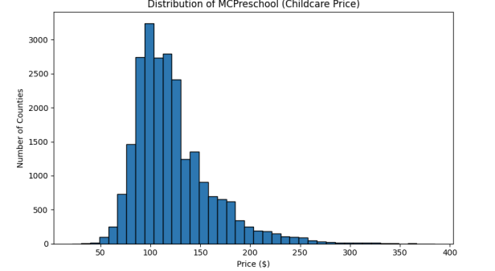
Regional Variation: The states with the highest median childcare prices include the District of Columbia, Rhode Island, Connecticut, Massachusetts, and New York. These states typically represent high-cost urban centers or regions with specialized services.
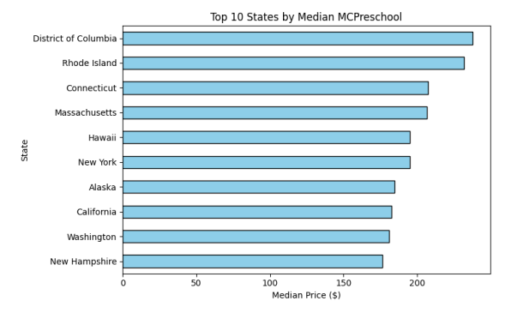
Median childcare prices by Age:
Center-based care (CBC) is generally more expensive than family child care (FCC) across all age groups. Infant care is the most costly, while preschool care is the least expensive option. As children get older, the prices for both types of care decrease. Family child care for preschool-age children has the lowest median cost, which is just under $100.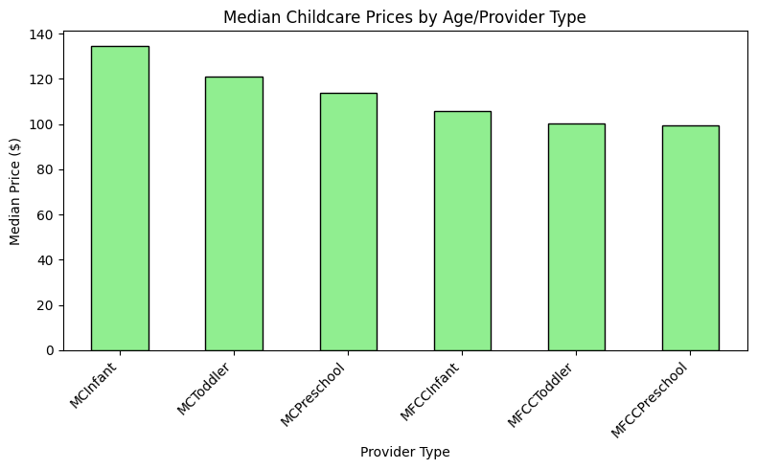
Trend of Childcare Prices Over Time:
Median childcare prices have shown a gradual upward trend over the years, highlighting a steady rise in childcare costs nationwide. Significant spikes or drops in prices may correspond to policy changes, economic events, or shifts in provider rates. Periods where the trend line flattens indicate stability in childcare pricing, suggesting market equilibrium or a lack of inflationary pressure during those times. Additionally, if there are multiple data points per year, small fluctuations may reflect seasonal variations in enrollment or fees.
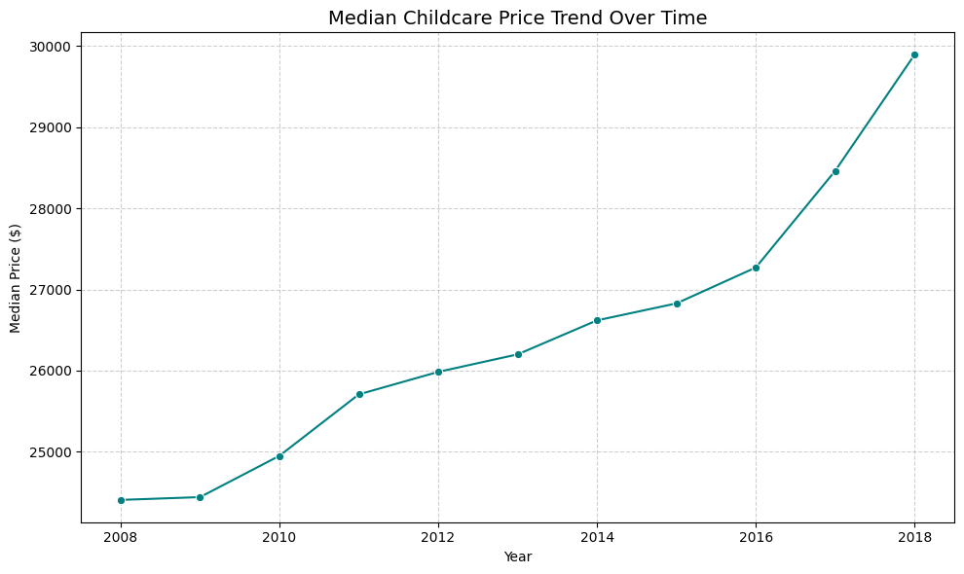
Heatmap of Median Prices by State and Year
The analysis of childcare costs across various states reveals several key insights. High-cost states are consistently represented in darker shades on the heatmap, indicating that these regions generally have the highest median childcare expenses, often due to their urbanized settings or elevated cost of living. Conversely, low-cost states, shown in lighter colors, typically represent smaller or more rural areas where demand for childcare services is lower. Examining temporal patterns, we can observe changes in the color intensity of certain states over the years, highlighting the evolution of childcare costs in different regions. Additionally, regional trends often emerge, with neighboring states demonstrating similar pricing trends, which underscores geographic patterns in affordability. It's also important to note any outliers; a sudden dark or light cell compared to surrounding years may signal anomalies, special programs, or discrepancies in reporting, warranting further investigation.
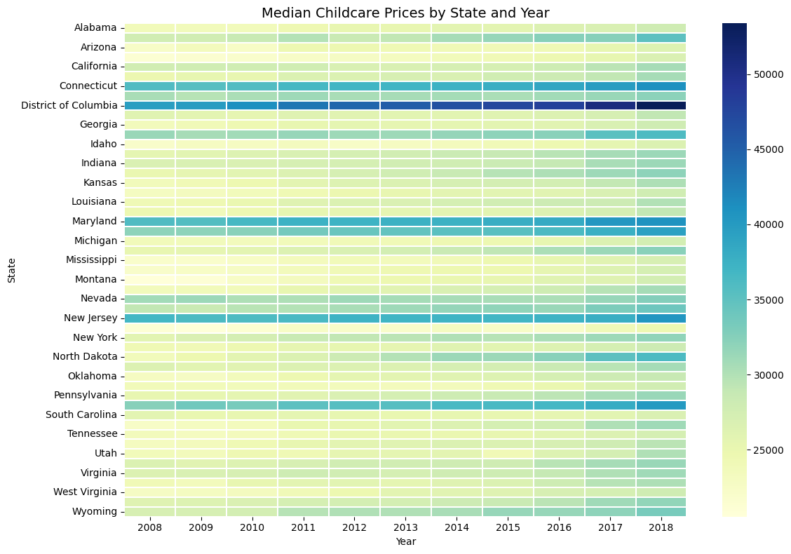
Median Childcare Prices Across U.S. State:
The choropleth map illustrates the variation in median childcare prices across different U.S. states. In the Northeast, states such as Massachusetts, Maryland, Connecticut, and New York exhibit the highest childcare costs, exceeding $40,000. Moving west, states like California, Hawaii, New Jersey, and Colorado fall into the moderate pricing category, with costs ranging from $30,000 to $40,000. In contrast, the South and Midwest showcase much lower prices, with states like Mississippi, Oklahoma, and Arkansas reporting costs below $25,000. This visual representation highlights the significant regional disparities in childcare expenses across the country.
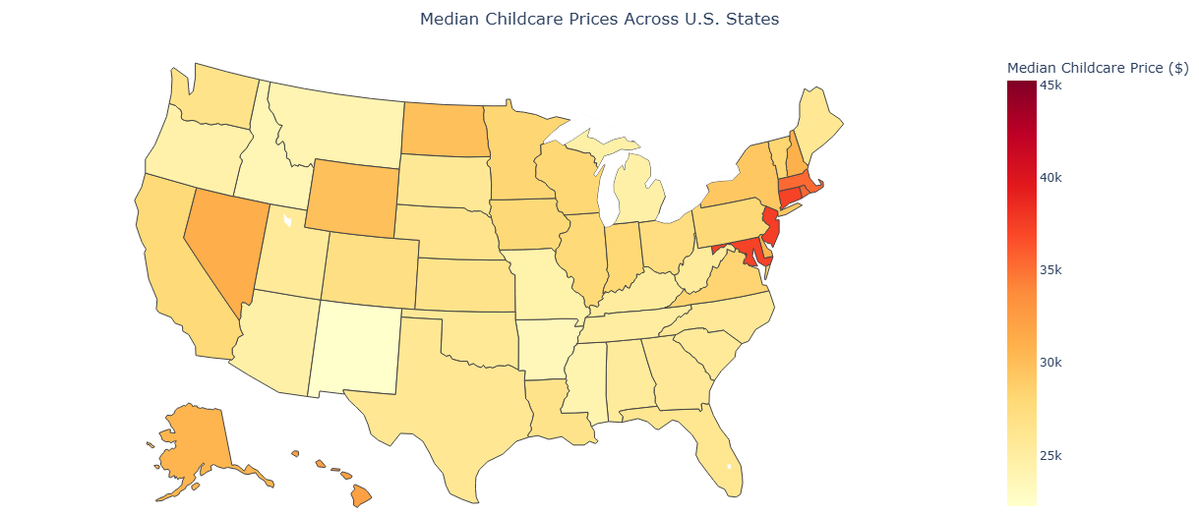

Explanation:
The visual choices were made to ensure clarity, consistency, and interpretability. We used bar charts and histograms to emphasize distribution and ranking, particularly highlighting the top ten states by childcare costs. Additionally, line charts and heatmaps were included to showcase both temporal and spatial variations.
Color palettes were selected for accessibility and contrast. "Sky blue" and "light green" were used for categorical comparisons to evoke clarity and neutrality, while sequential colormaps like "YlGnBu" and "Teal" were applied for time trends and heatmaps, illustrating gradual changes intuitively.
Each chart was carefully sized between 8 to 12 inches wide to ensure legibility without overcrowding the visuals. Axes were labeled with clear units (in USD and years), and subtle gridlines were applied to enhance readability without causing distraction. Titles were formatted uniformly to create a cohesive presentation.
The addition of line charts and heatmaps complements the existing visuals by expanding the narrative from static price comparisons to dynamic change analysis. Together, these visuals provide a comprehensive view of how childcare costs vary by provider type, state, and year, offering actionable insights for both policymakers and families.
Challenges/Issues:
The primary challenges faced in this project was managing the size and complexity of the National Database of Childcare Prices. This database contains a vast number of variables and county-level observations spanning multiple years. The high dimensionality of the dataset required careful feature selection to avoid overcrowded or misleading visualizations.
Additionally, several childcare cost variables had missing values for specific counties or years, which necessitated thoughtful filtering and aggregation decisions to maintain data integrity while ensuring interpretability. Aggregating data from the county level to the state level improved clarity for visualization, but it also introduced the risk of masking important disparities within states.
Finally, the lack of inflation-adjusted pricing limited our ability to assess real cost changes over time. As a result, the analysis had to focus on nominal trends rather than true differences in purchasing power.
References:
The project will be supported and validated through the use of the following resources:
- The childcare cost dataset from Kaggle (https://www.kaggle.com/datasets/sujaykapadnis/childcare-costs/discussion)
- Data.gov. Childcare Prices Datasets(https://catalog.data.gov/dataset/?tags=childcare-prices)

